SMART HOME SYSTEM

CIRCUIT DIAGRAM :

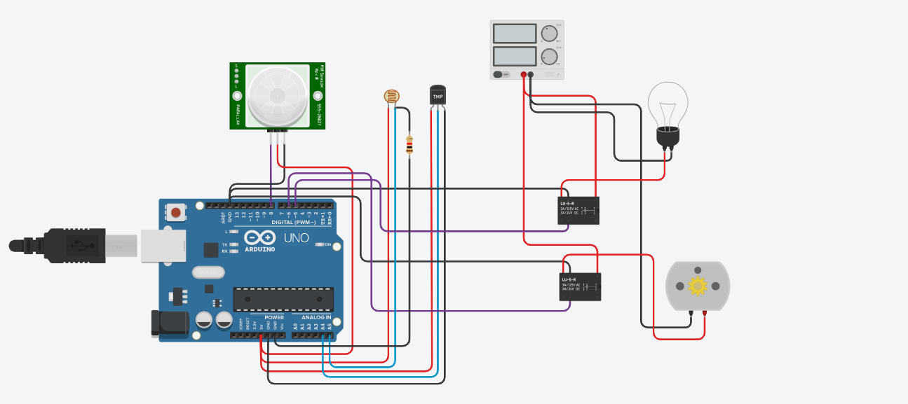

float x,y,z,temp;

void setup()

{

pinMode(8, INPUT);

pinMode(5, OUTPUT);

pinMode(6, OUTPUT);

pinMode(A5, INPUT);

pinMode(A4, INPUT);

Serial.begin(9600);

}

void loop()

{

x= digitalRead(8);

y= analogRead(A5);

z= analogRead(A4);

Serial.println(x);

Serial.println(y);

Serial.println(z);

temp = (double)z / 1024;

temp = temp * 5;

temp = temp - 0.5;

temp = temp * 100;

if ( (x>0) )

{

if ((y<550)&&(temp>30))

{

digitalWrite(5, HIGH);

digitalWrite(6, HIGH);

}

else if((y<550)&&(temp<30))

{

digitalWrite(5, HIGH);

digitalWrite(6, LOW);

}

else if((y>550)&&(temp>30))

{

digitalWrite(5, LOW);

digitalWrite(6, HIGH);

}

else if((y>550)&&(temp<30))

{

digitalWrite(5, LOW);

digitalWrite(6, LOW);

}

}

else

{

digitalWrite(5, LOW);

digitalWrite(6, LOW); } }

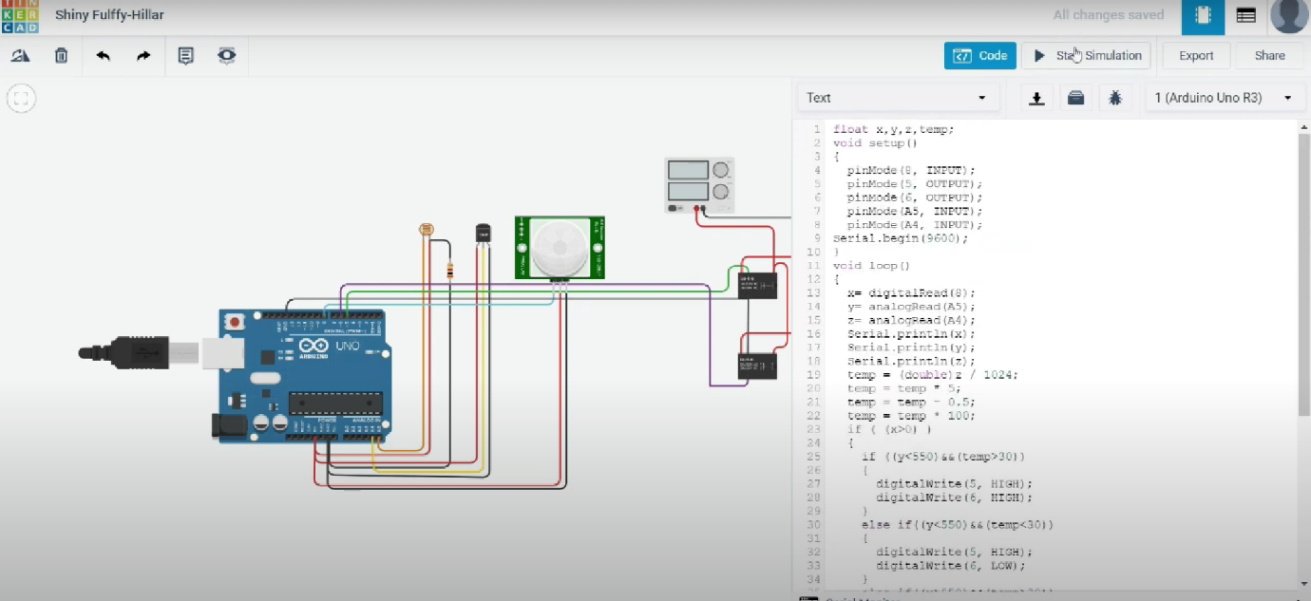

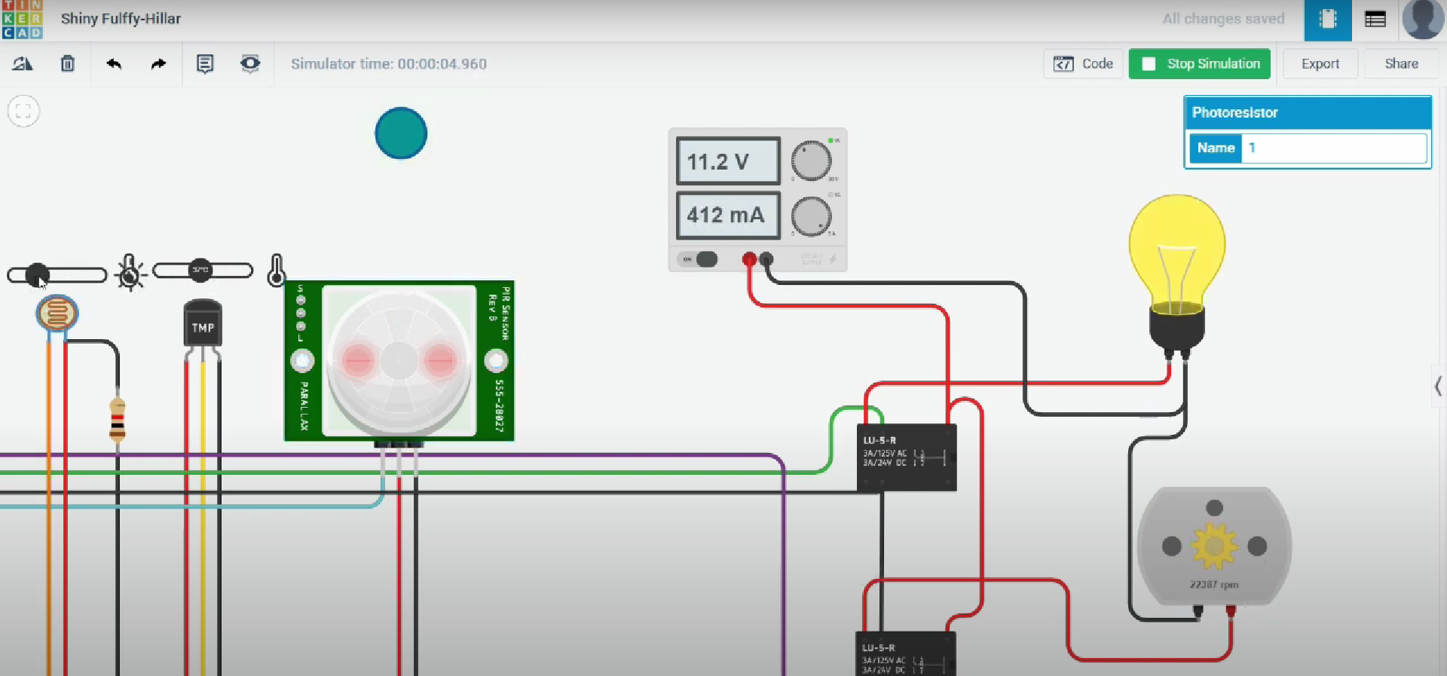

When a person is infront of PIR sensor then this detects the heat and then the whole system starts to work . The temperature sensor senses the temperature and makes the motor to run which operates the fan .The Photoresistor switches on the light bulb if the values fall below the threshold (550 in this case).

https://www.tinkercad.com/things/jzxbLUlaQXX-funky-bombul/editel?sharecode=6L46oGrXZWN5tiI9YyLyuhfcEFZ1u99_DUrr_au0Aaw